Resume

Name of Teaching Staff | Prof. Shital Dilip Sonawane |  |  | 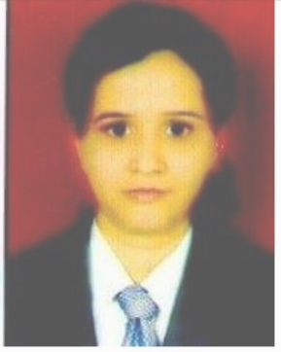
Institute Name | PDEA`S Mahatma Phule Institute of Management and Computer Studies, Hadapsar, Pune.
Designation | Assistant Professor
Department | MBA
Area of Specialization | HR
Date of Joining the  Institute | 22/01/2019
Qualifications with Class/Grade | UG  B.E  (ENTC) | Second class | PG  (MBA) | Higher second Class
Total Experience in  Years | Teaching | 04 | Industry | 1 Yrs
Paper Published | National | 05 | International | 01

